**English 379/Cultural Studies 340** – 2021/22 Term I – Instructor: David Jefferess

Assignment: Colonial Legacies Project

**Description and Purpose:**

This assignment is inspired by Helen Haig-Brown’s Legacy project. As a Tsilhoqot’in person, Helen Haig-Brown’s initiative focuses on “**honouring, healing, renewing, and transforming our Indigenous legacy.” (**<http://muskratmagazine.com/my-legacy-interview-with-courageous-filmmaker-helen-haig-brown/>). Haig-Brown’s documentary is much more personal and introspective than what I expect from you, but the aim of the project is to think about how the impacts of colonialism and struggles for decolonization impact our lives.In the course, we will talk about this in terms of decolonization, indigenization, and cultural resurgence/revitalization, as a response to historical and ongoing structures of colonialism. Following the Final Report of the Canadian Truth and Reconciliation Commission on Indian Residential Schools, it is increasingly important for Indigenous and non-Indigenous peoples alike to examine the legacies of colonialism in their lives and communities. All people who are resident in what is currently Canada, and most people in the world, have had their lives impacted by colonialism. ***This assignment seeks to identify, engage with, and reflect upon the impact of colonialism on our lives. Hopefully, it will provide a means of acknowledgement, understanding, healing, and/or revitalization.***

*Individual Reflection and Learning:* This assignment is designed to allow students to critically reflect on *their* experience of colonialism, recognizing that colonialism is ongoing in the Okanagan, in Canada, and in the world, and that we experience legacies of previous manifestations of colonialism. Students will undertake research individually (or in pairs), with varying degrees of personal self-reflection, utilizing concepts, ideas, and approaches from course readings.

*Collaborative (Alter)Knowledge-Making:* Students will be assigned workshop groups for the final project, providing feedback on proposals, and then reconvening again in the final class to discuss their projects, making connections and drawing out key ideas that they will present (informally) to the class.

*Communication Beyond the Classroom:* This assignment is potentially very personal, yet I want you to think of it not as something produced for a professor for a grade but for other possible audiences. The primary audience may be yourself. Or it may be your family/friends. Or it may be a wider public audience. The form of your project will be informed by the audience you seek to reach.

This assignment values both the final *product* (the communication of research) and the *process* of learning and working with others to develop a research project. It requires academic research, and the engagement with scholarship on colonialism and decolonization, but also allows for other forms of expression.

**General Expectations:**

* Students will select one of the possible approaches (below) and work individually or in pairs to develop a project in response to that approach.
* Students will be organized into workshop groups, as identified above, and will be expected to contribute to their collaborative teams

**Required elements of the project:**

***Reflection Guides* 8%**

Graded for Completion (0=incomplete, 1=partially complete, 2=complete). Submit it on Canvas by the due date. Reflection guides available in the Assignments module on Canvas. These guides will invite you to engage with course material and provide pre-research that will hopefully help you do formulate a project.

**Approaches to the Project:**

Select ONE of the following approaches or talk with David about how to combine more than one approach.

***Personal/Family Legacies****:* This approach invites you to examine your personal and family histories of colonialism. Students who are from Turtle island, might reflect on their positioning as Indigenous, as settlers, immigrants/arrivants, or complicated mixes of these kinds of family lineages. In my case, this might mean researching Richard Beasley, an ancestor of mine, who was one of the first European settlers at the head of Lake Ontario, or it might mean talking with my brother about why this lineage is so important to him today. For some students, this approach might focus on *acknowledging* how their family histories, and hence their own lives, are imbricated in colonialism as “explorers,” early settlers, or immigrants who benefited from the displacement of Indigenous peoples; for some students it might focus on how their family histories reflect resistance, resilience, and cultural resurgence, in the face of colonialism. Of course, there are many other possibilities. *You will want to analyze the stories and images of your family past, utilizing theories and concepts from the course and research.*

***Community Legacies*:** This approach invites you to examine a specific community you are part of and think about how it has been shaped by, or is a product of, (ongoing) colonialism, and how this has shaped who you are. For instance, you might examine the name of your town/city or the names of the streets in your community, how “heritage” and culture are constructed in your community and the extent to which, and how, colonialism is acknowledged in that heritage. Or you might seek to research the history of your discipline (e.g. English, Psychology, etc.), and the way your discipline is configured at this university, to examine how it engages with and/or is shaped by (ongoing) colonialism. Or you might identify another community you belong to; once, someone examined the colonial imagery and themes in video games, critically reflecting on the way colonialism is normalized in gaming communities. *Your analysis must utilizing theories and concepts from the course as well as research.*

***Alternative Futures:*** In this approach, you can imagine how the legacy of colonialism may be undermined in your own life, that of your community, or academic discipline, etc. (See above). So, in this approach you focus more on the future than the past, imagining tangible ways that colonialism can be challenged and decolonization envisioned and enacted. *You will need to utilize theories and concepts from the course and research.*

***Proposal 8%***

Each student/pair will submit a concise but specific ONE-PAGE (single-spaced) proposal for their project that will include:

1. A **rationale** for their approach to the topic, providing a clear explanation of how they will approach the topic they have selected, and why;
2. A description of the project they plan to complete/approach they plan to use; for instance, scholarly essay, personal essay, podcast, oral presentation, animated video, workshop, zine, etc. (The project should be the equivalent to a 2000-word essay, so it is important to be specific in your plans and to follow David’s advice on your communication plan).
3. Identification of the intended **audience** for your project (family, the general public, other university students, specific community or cultural groups, yourself). *Note: you need not present your assignment to this audience, but you need to create it with this audience in mind, recognizing that David will evaluate it.*
4. A **description of the specific theories, ideas, and concepts** from the course that will help to support their project.
5. A **description of the research required** to undertake the project. (e.g. research about the origins of English as an academic discipline; Interviews with family; etc.)

**Project - 30%**

1. The project – The communication of your research and analysis in the mode you identified in the proposal and modified based on David’s feedback
   1. Equivalent of a 2000-word academic essay
   2. Format: (Depends upon the form of communication)
   3. Citation: You MUST cite in a form appropriate to the mode of communication. An academic essay should use MLA or Chicago author-date, an essay designed for online publication can use hyper-links and footnotes, an oral presentation can clearly identify sources in the presentation, etc.
   4. All assignments must include a complete bibliography of research sources, using MLA or another established academic format.

**Research:**

This assignment requires you to utilize concepts, theories, and ideas from course readings in order to help you interpret or make meaning of the particular stories and material you utilize in your research. The project requires you to undertake some form(s) of research beyond the course, including the use of academic articles and books, or archival research (museum archives, databases, ancestry websites), etc. Some approaches may also require interviewing family members. David will seek **Behavioural Research Ethics Board Approval** for interview-based research; if you plan to use **interviews** for your research please contact David as soon as possible, as you will need to complete some basic online training and work with David to fulfill university regulations.

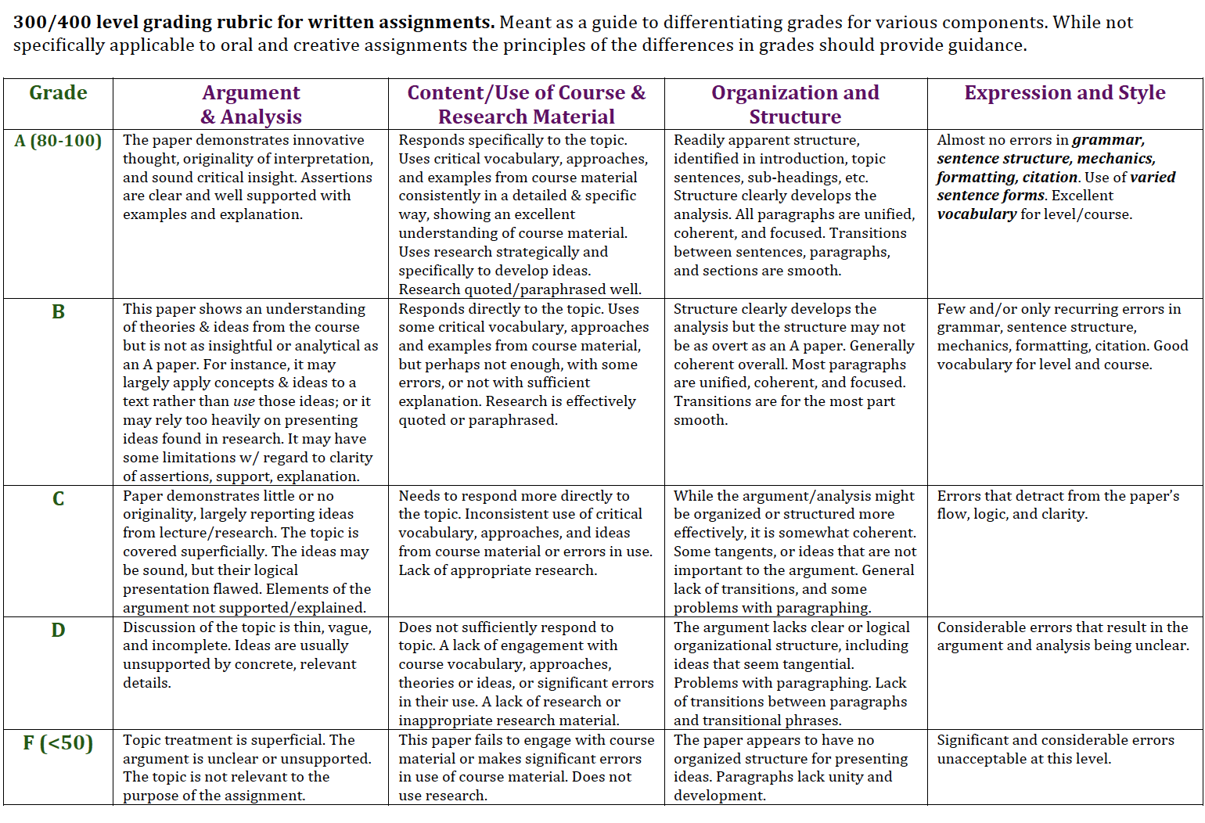

**Deadlines:**

* Inform David of your planned topic and approach, and receive approval **no later than 10 November.**
* Proposal and Peer Feedback: **Submit Proposal to group members on the Canvas Discussion board for your assigned group by 13 November; Submit to David via Canvas assignment dropbox by 17 November**
* Project and paper: **10 December *– A*ssignment dropbox on Canvas or alternative negotiated with David**

**I am happy to chat with you about your ideas for this project so do not hesitate to make an appointment, drop by my office hours, or to send me an email with some of your thoughts.**